Task 24-07-2022 solution

select * from task240722.dressdataset;

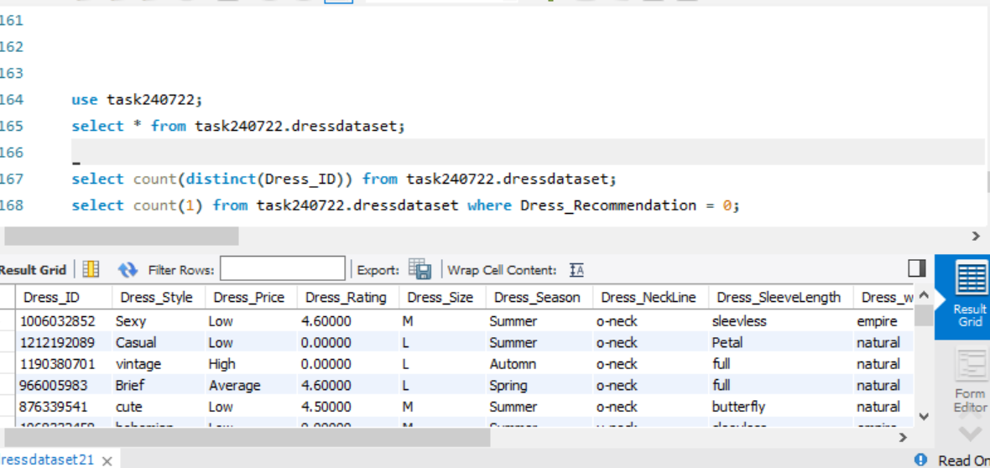

select * from task240722.dresssales;

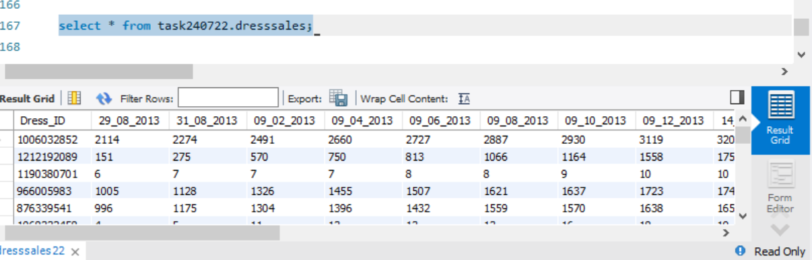

Q6 : In SQL task try to perform left join operation with Attribute Dataset and Dress Dataset on column Dress Id

left - Attribute

Right – Dress

select *

from task240722.dressdataset a

left join dresssales as b

on a.Dress_ID = b.Dress_ID

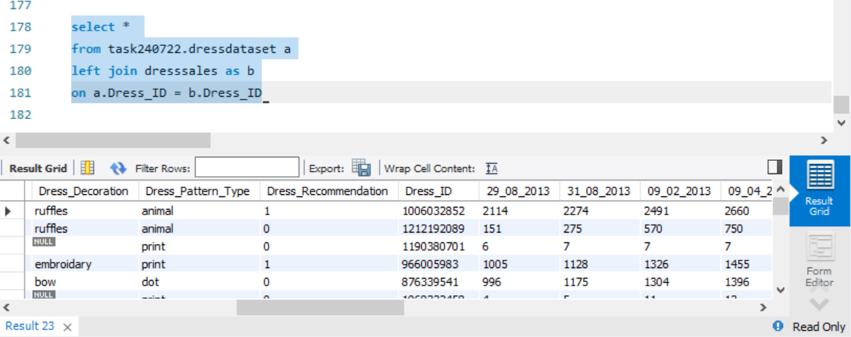

7. Write a SQL query to find out how many unique dress that we have based on dress id

select count(distinct(Dress_ID)) from task240722.dressdataset;

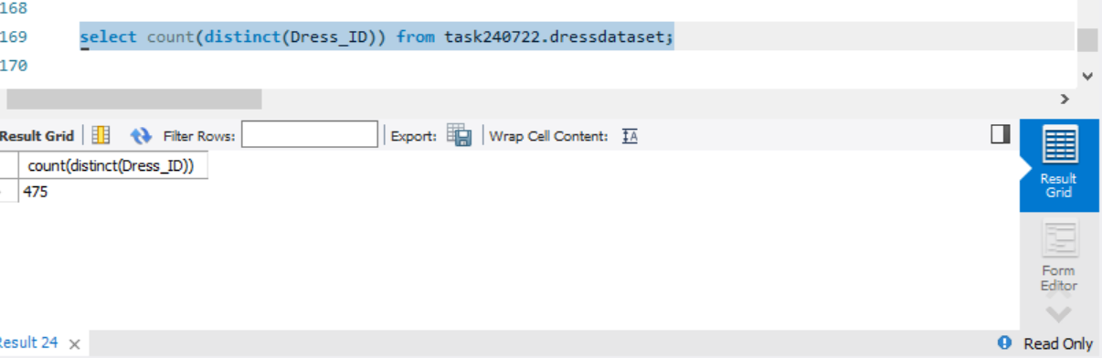

8. Try to find out how many dress is having recommendation 0.

select count(1) from task240722.dressdataset where Dress_Recommendation = 0;

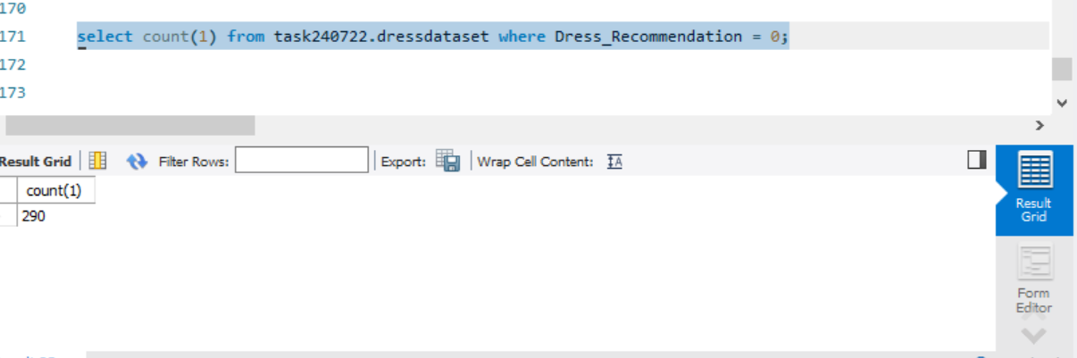

9. Try to find out total dress sales for each dress id using My SQL.

select Dress_Id , sum(29_08_2013 +31_08_2013 +09_02_2013 +09_04_2013 +09_06_2013 +09_08_2013 +09_10_2013 +09_12_2013 +14_09_2013 +16_09_2013 +18_09_2013 +20_09_2013 +22_09_2013 +24_09_2013 +26_09_2013 +28_09_2013 +30_09_2013 +10_02_2013 +10_04_2013 +10_06_2013 +10_08_2010 +10_10_2013 +10_12_2013) as total_sales from task240722.dresssales group by Dress_ID;

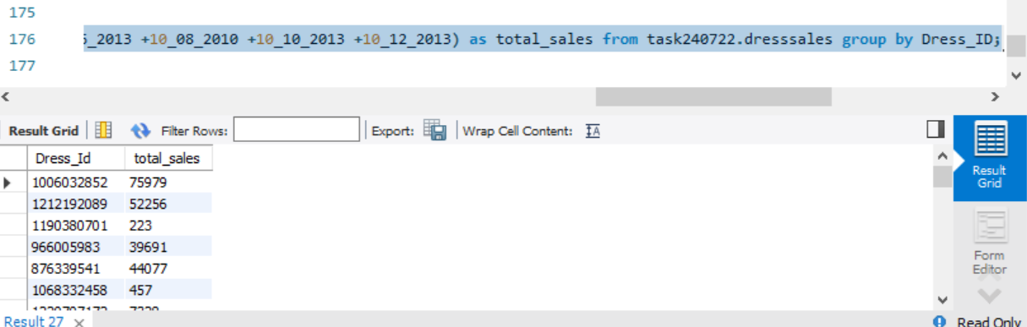

10. Try to find out a third highest most selling dress.

select Dress_Id , sum(29_08_2013 +31_08_2013 +09_02_2013 +09_04_2013 +09_06_2013 +09_08_2013 +09_10_2013 +09_12_2013 +14_09_2013 +16_09_2013 +18_09_2013 +20_09_2013 +22_09_2013 +24_09_2013 +26_09_2013 +28_09_2013 +30_09_2013 +10_02_2013 +10_04_2013 +10_06_2013 +10_08_2010 +10_10_2013 +10_12_2013) as total_sales from task240722.dresssales group by Dress_ID order by total_sales desc;

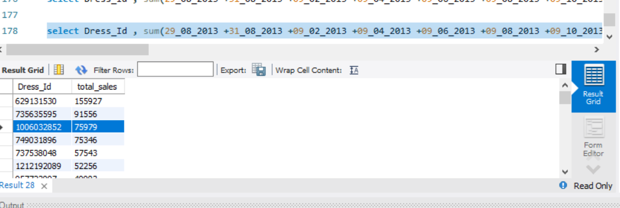

Third highest =

|  |
| --- |
| Dress Id : 1006032852  Total Sales : 75979 |